Código m.file

function varargout = practica(varargin)

% PRACTICA M-file for practica.fig

% PRACTICA, by itself, creates a new PRACTICA or raises the existing

% singleton*.

%

% H = PRACTICA returns the handle to a new PRACTICA or the handle to

% the existing singleton*.

%

% PRACTICA('CALLBACK',hObject,eventData,handles,...) calls the local

% function named CALLBACK in PRACTICA.M with the given input arguments.

%

% PRACTICA('Property','Value',...) creates a new PRACTICA or raises the

% existing singleton*. Starting from the left, property value pairs are

% applied to the GUI before practica_OpeningFcn gets called. An

% unrecognized property name or invalid value makes property application

% stop. All inputs are passed to practica_OpeningFcn via varargin.

%

% *See GUI Options on GUIDE's Tools menu. Choose "GUI allows only one

% instance to run (singleton)".

%

% See also: GUIDE, GUIDATA, GUIHANDLES

% Edit the above text to modify the response to help practica

% Last Modified by GUIDE v2.5 04-Jan-2010 22:00:24

% Begin initialization code - DO NOT EDIT

gui_Singleton = 1;

gui_State = struct('gui_Name', mfilename, ...

'gui_Singleton', gui_Singleton, ...

'gui_OpeningFcn', @practica_OpeningFcn, ...

'gui_OutputFcn', @practica_OutputFcn, ...

'gui_LayoutFcn', [] , ...

'gui_Callback', []);

if nargin && ischar(varargin{1})

gui_State.gui_Callback = str2func(varargin{1});

end

if nargout

[varargout{1:nargout}] = gui_mainfcn(gui_State, varargin{:});

else

gui_mainfcn(gui_State, varargin{:});

end

% End initialization code - DO NOT EDIT

% --- Executes just before practica is made visible.

function practica_OpeningFcn(hObject, eventdata, handles, varargin)

% This function has no output args, see OutputFcn.

% hObject handle to figure

% eventdata reserved - to be defined in a future version of MATLAB

% handles structure with handles and user data (see GUIDATA)

% varargin command line arguments to practica (see VARARGIN)

% Choose default command line output for practica

handles.output = hObject;

% Update handles structure

guidata(hObject, handles);

initialize_gui(hObject, handles, false);

% UIWAIT makes practica wait for user response (see UIRESUME)

% uiwait(handles.figure1);

% --- Outputs from this function are returned to the command line.

function varargout = practica_OutputFcn(hObject, eventdata, handles)

% varargout cell array for returning output args (see VARARGOUT);

% hObject handle to figure

% eventdata reserved - to be defined in a future version of MATLAB

% handles structure with handles and user data (see GUIDATA)

% Get default command line output from handles structure

varargout{1} = handles.output;

% --- Executes on button press in filtro.

function filtro_Callback(hObject, eventdata, handles)

% hObject handle to filtro (see GCBO)

% eventdata reserved - to be defined in a future version of MATLAB

% handles structure with handles and user data (see GUIDATA)

global t Y fs r se;

e=r-Y; %restamos la (señal con ruido) menos (entrenamiento)

axes(handles.graf_recuperada);

cla;

if(1==get(handles.espectro,'value'));

sfe=fft(e,512);

ef=((0:255)/256*(fs/2));

sfeesp=abs(sfe);

plot(ef,sfeesp(1:256));

else

plot(e);

end

grid on;

dif=e-se;

axes(handles.diferencia_senal);

cla;

if(1==get(handles.espectro,'value'));

sfdif=fft(dif,512);

diff=((0:255)/256*(fs/2));

sfdifesp=abs(sfdif);

plot(diff,sfdifesp(1:256));

else

plot(dif);

end

grid on;

soundsc(e,fs);

% --- Executes on button press in selec_audio.

function selec_audio_Callback(hObject, eventdata, handles)

% hObject handle to selec_audio (see GCBO)

% eventdata reserved - to be defined in a future version of MATLAB

% handles structure with handles and user data (see GUIDATA)

set(handles.selec_audio,'value',1)

set(handles.grabar,'value',0)

% Hint: get(hObject,'Value') returns toggle state of selec_audio

% --- Executes on button press in grabar.

function grabar_Callback(hObject, eventdata, handles)

% hObject handle to grabar (see GCBO)

% eventdata reserved - to be defined in a future version of MATLAB

% handles structure with handles and user data (see GUIDATA)

set(handles.selec_audio,'value',0)

set(handles.grabar,'value',1)

% Hint: get(hObject,'Value') returns toggle state of grabar

% --- Executes on button press in aceptar_senal.

function aceptar_senal_Callback(hObject, eventdata, handles)

% hObject handle to aceptar_senal (see GCBO)

% eventdata reserved - to be defined in a future version of MATLAB

% handles structure with handles and user data (see GUIDATA)

global tam1 se fs;

if( 0 ==get(handles.selec_audio,'value'));

duracion = 4; %TIEMPO DE ADQUISION DE DATOS

Fs = 44100; %constante segun el uso del comando 8000, 11025, 22050, and 44100 Hz

grab = wavrecord(duracion*Fs,Fs,1);

[filename,pathname] = uiputfile('grabado.wav','Save file name');

wavwrite(grab,Fs,8,'grabado');

else

[filename, pathname] = uigetfile('*.wav','select a wave file to load');

end

[se,fs,NBITS1]= wavread([pathname filename]);

se=se';

tam1=size(se)-1;

axes(handles.graf_senal);

cla;

if(1==get(handles.espectro,'value'));

sfse=fft(se,512);

sef=((0:255)/256*(fs/2));

sfseesp=abs(sfse);

plot(sef,sfseesp(1:256));

else

plot(se);

end

grid on;

%soundsc(se,fs);

% --- Executes on selection change in tipo_ruido.

function tipo_ruido_Callback(hObject, eventdata, handles)

% hObject handle to tipo_ruido (see GCBO)

% eventdata reserved - to be defined in a future version of MATLAB

% handles structure with handles and user data (see GUIDATA)

global w tam1 fs t Y;

freq=3000;

t=(0:tam1(1,2))/fs;

if( 1 == get(handles.tipo_ruido,'value'))

w=sin(freq*2*pi*t);

load '0.001senoidal_Y.mat' Y;

end

if( 2 == get(handles.tipo_ruido,'value'))

w=cos(freq*2*pi*t);

end

if( 3 == get(handles.tipo_ruido,'value'))

w=randn(1,tam1(1,2)+1);

end

% Hints: contents = cellstr(get(hObject,'String')) returns tipo_ruido contents as cell array

% contents{get(hObject,'Value')} returns selected item from tipo_ruido

% --- Executes during object creation, after setting all properties.

function tipo_ruido_CreateFcn(hObject, eventdata, handles)

% hObject handle to tipo_ruido (see GCBO)

% eventdata reserved - to be defined in a future version of MATLAB

% handles empty - handles not created until after all CreateFcns called

% Hint: popupmenu controls usually have a white background on Windows.

% See ISPC and COMPUTER.

if ispc && isequal(get(hObject,'BackgroundColor'), get(0,'defaultUicontrolBackgroundColor'))

set(hObject,'BackgroundColor','white');

end

% --- Executes on button press in aceptar_ruido.

function aceptar_ruido_Callback(hObject, eventdata, handles)

% hObject handle to aceptar_ruido (see GCBO)

% eventdata reserved - to be defined in a future version of MATLAB

% handles structure with handles and user data (see GUIDATA)

global w fs t tam1;

t=(0:tam1(1,2))/fs;

axes(handles.graf_ruido);

cla;

if(1==get(handles.espectro,'value'));

sfw=fft(w,512);

wf=((0:255)/256*(fs/2));

sfwesp=abs(sfw);

plot(wf,sfwesp(1:256));

else

plot(w);

end

grid on;

%soundsc(w,fs);

% --- Executes on button press in sumar_senal.

function sumar_senal_Callback(hObject, eventdata, handles)

% hObject handle to sumar_senal (see GCBO)

% eventdata reserved - to be defined in a future version of MATLAB

% handles structure with handles and user data (see GUIDATA)

global se w r fs;

r=se+w; %sumamos la señal y ruido

r=r/max(r); % normalizamos la señal sumada

axes(handles.graf_suma);

cla;

if(1==get(handles.espectro,'value'));

sfr=fft(r,512);

rf=((0:255)/256*(fs/2));

sfresp=abs(sfr);

plot(rf,sfresp(1:256));

else

plot(r);

end

grid on;

%soundsc(r,fs);

% --- Executes on button press in entrenar.

function entrenar_Callback(hObject, eventdata, handles)

% hObject handle to entrenar (see GCBO)

global r w Y;

f=msgbox('Entrenando sistema.','Busy');

P=con2seq(w); % ruido %Hacemos en filas, no en columnas

T=con2seq(r); %senal mas ruido %r= senal mas ruido, w= ruido

net=newlin([-1 1],1,[0 2],0.08); %Definimos valores max, min y 1 neurona, Error mínimo: 0.08 en base a varia pruebas

net.adaptParam.epoch=20;

net.IW{1,1}=rands(1,2);

net.b{1}=[0];

[net,Y,E,Pf]=adapt(net,P,T); %entrenamos a la red como entrada el ruido y como valor esperado se;al mas ruido

Y=cell2mat(Y);

delete(f)

% eventdata reserved - to be defined in a future version of MATLAB

% handles structure with handles and user data (see GUIDATA)

function initialize_gui(fig_handle, handles, isreset)

global w;

global fs;

global tam1;

global se;

set(handles.selec_audio,'value',1)

set(handles.grabar,'value',0)

set(handles.onda,'value',1)

set(handles.espectro,'value',0)

RESULTADOS

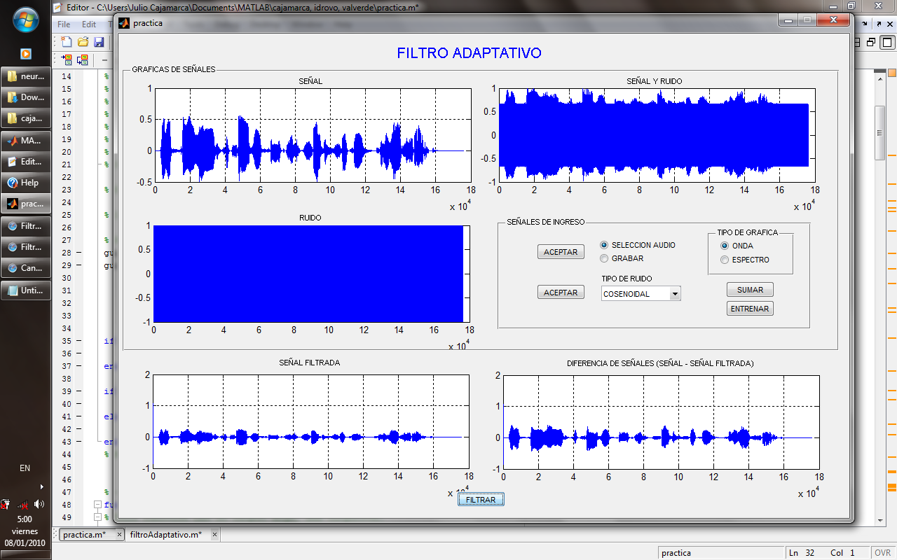





ANALISIS EN EL DOMINIO DEL TIEMPO

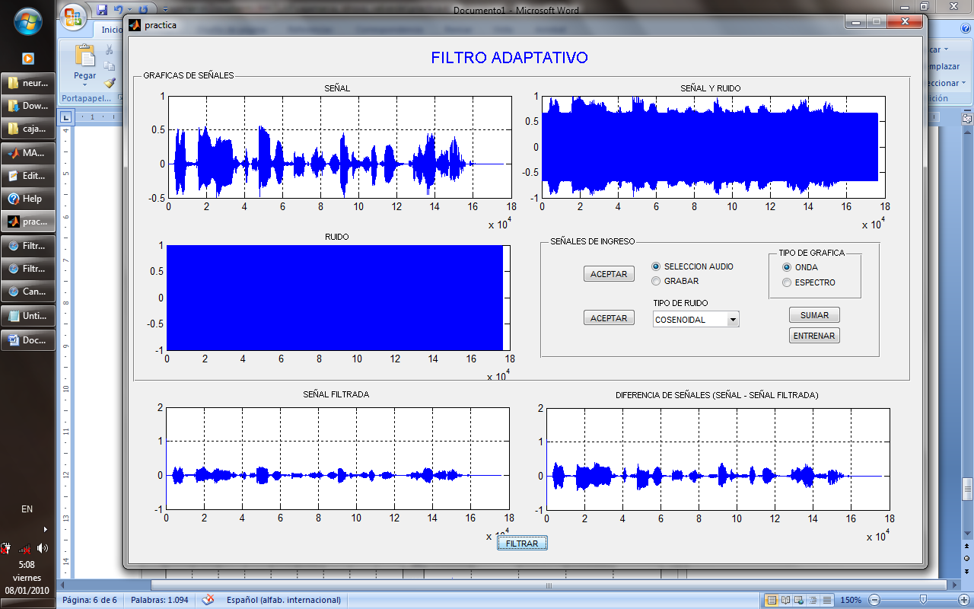

ANALISIS ESPECTRAL

